2017 Mixtape
Leelanau Peninsula- Michigan
Mixtape is a field blend of several varietals. We fermented this wine at cooler temperature to capture the fresh fruit aromas. Balanced with a touch of sweetness, this wine will have you pining for auto-reverse.
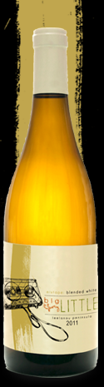
The Grapes
Single Vineyard, Field Blend
25% each Riesling, Gewurztraminer,
Pinot Blanc
20% Pinot Gris
5% Pinot Noir

Winemaking
Harvested, crushed, and pressed together 10/18/2017.
Cool, stainless ferment halted at 1.3% RS

The Wine

Finished with 1.3% residual sugar, this off-dry wine displays aromas of grapefruit and white pepper; crisp and tropical with a balanced finish.

600 Cases Produced
$17.00 750ml

